- Tên và phân loại:

- Mục đích, ý nghĩa:
Separate the construction of a complex object from its representation so that the same construction process can create different representations.
- Động lực sử dụng:
- Consider problem of reading an RTF file and converting it to
one of a number of different formats.
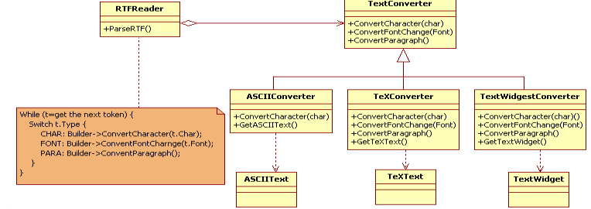
- Khi nào sử dụng:
- The algorithm for creating a complex object should be independent of the parts that make up the object and how they're assembled
- The construction process must allow different representations for the object that's constructed
- Cấu trúc
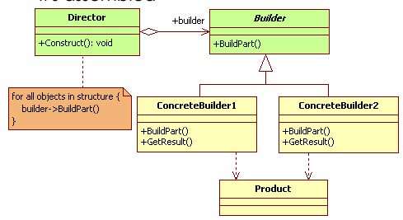
- Các thành viên - Sự cộng tác
- Builder: specifies an abstract interface for creating parts of a Product object
- ConcreteBuilder
• Constructs and assembles parts of the product by implementing the Builder interface
• Defines and keeps track of the representation it creates
• Provides an interface for retrieving the product
- Director: Constructs an object using the Builder interface
- Product: Represents the complex object under construction. ConcreteBuilder
builds the product's internal representation and defines the process by which
it's assembled
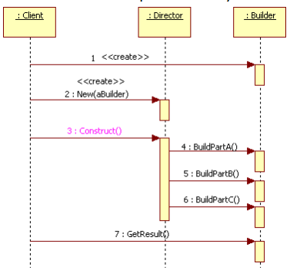
- Các hệ quả mang lại:
- Lets you vary a product's internal representation
• The Builder object provides the director with an abstract interface
for constructing the product
• The interface lets the builder hide the representation and internal
structure of the product. It also hides how the product gets
assembled
• Because the product is constructed through an abstract
interface, all you have to do to change the product's internal
representation is define a new kind of builder
- Isolates code for construction and representation
• Improves modularity by encapsulating the way a complex object
is constructed and represented
• Clients doesn‟t need to know anything about the classes that
define the product's internal structure; such classes don't appear
in Builder's interface
- Gives you finer control over the construction process
• Unlike creational patterns that construct products in one shot, the
Builder pattern constructs the product step by step under the
director's control
• Only when the product is finished, the director retrieves it from the
builder
• Hence the Builder interface reflects the process of constructing
the product more than other creational patterns. This gives you
finer control over the construction process and consequently the
internal structure of the resulting product
- Chú ý liên quan đến cài đặt:

- Hệ thống thực tế

- Mẫu liên quan
- Abstract Factory is similar to Builder in that it too may construct complex objects. The primary difference is:
• The Builder pattern focuses on constructing a complex object step by step. Abstract Factory's emphasis is on families of product objects (either simple or complex).
• Builder returns the product as a final step, but as far as the Abstract Factory pattern is concerned, the product gets returned immediately.
- A Composite is what the Builder often builds.

